Pliers ( generally for the lab)

Bird Beak plier for hard wires(AO 001-E 139 or similar)

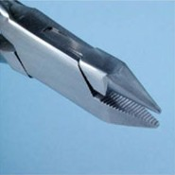 Also called Adams plier for the lab

Lingual arch forming plier (AO 678-309A or similar)



------------------------------------------------------------------------------------------------------------

Cutter for hard wire

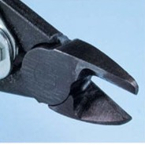 

(it is not used in the mouth,so also a not expensive one available in a hardware store)

------------------------------------------------------------------------------------------------------------

Orthodontic Pliers

Weingart plier

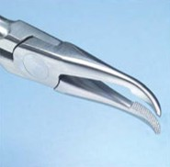 

-----------------------------------------------------------------------------------------------------

Bird beak plier for light wires (AO 001-E140 or similar)

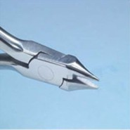 

Also called Angle plier

De La Rosa plier (AO 678-310A or similar)

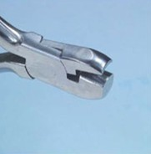 Also called concave-convex plier.

------------------------------------------------------------------------------------------------------------

Hold distal end cutter (AO 678-101A)

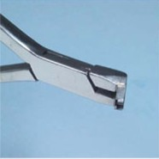 

------------------------------------------------------------------------------------------------------------

**Mathieu plier**

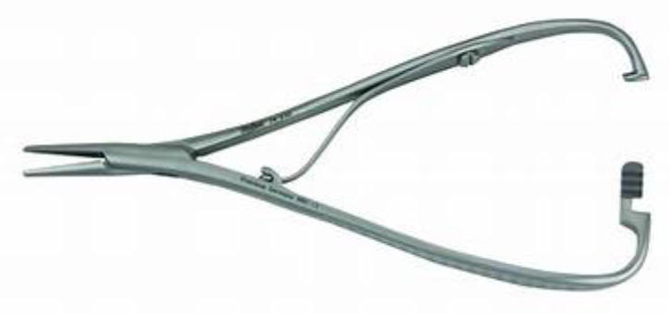

------------------------------------------------------------------------------------------------------------

**Ligature cutter (AO 678-107 A or similar)**

